Low-Level Design (LLD) — Spare Parts Consumption Module
Attribute | Value
Module | Spare Parts Consumption
Menu path | After Market → Spare Parts Consumption
Application | Complaint / Dealer Portal (After Market)
Stack (target) | Core PHP + MySQL (PDO)
Stack (current repo) | Core PHP + PostgreSQL via PDO (pdo_obconn.php) — schema maps 1:1 to MySQL
Document version | 1.0
Related modules | Installed Base Capture, Service Log Capture, RBAC, System Config Master

────────────────────────────────

1. Module Overview

1.1 Purpose
Spare Parts Consumption records parts consumed against a machine (Installed Base), optionally linked to a Service Log: consumption date, warranty/chargeable type, running hours, remarks, and one or more line items (spare kit number, reason, quantity, order value). It can be created from the dedicated listing page or from Add Spare Parts actions on Installed Base / Service Log rows.

1.2 Scope
In scope | Out of scope
Create / update / soft-delete consumption headers + items | Hard delete / inventory stock deduction
Multi-item spare kit rows (unlimited) | Spare kit master / catalog Select2 (kit is free text)
Server-side DataTable listing with after-market scope | Pricing engine beyond entered order value
Prefill from Installed Base or Service Log modals | Cascade delete when IB/SL is soft-deleted
Optional Service Log link (must belong to selected IB) | Order booking (Order ID hidden / not stored on parent)

1.3 High-level architecture
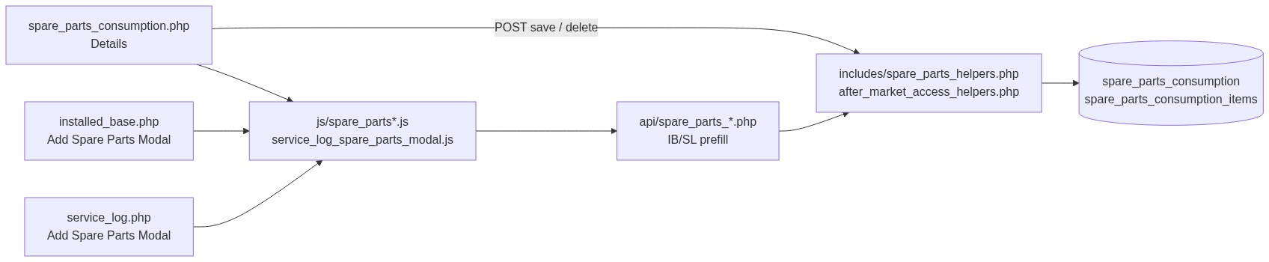
Figure 1 — High-level architecture
────────────────────────────────

2. Functional Requirements
ID | Requirement | Priority
FR-01 | Users with view can open listing and details | Must
FR-02 | Users with spare-parts add or IB add-spare-parts-consumption can create records | Must
FR-03 | Users with edit can update accessible records | Must
FR-04 | Users with delete can soft-delete accessible records (parent + items) | Must
FR-05 | Listing is server-side searchable/sortable (DataTables) | Must
FR-06 | Installed Base (machine) is mandatory and must be accessible | Must
FR-07 | Service Log is optional; if set, must belong to selected IB | Must
FR-08 | Fab Number must match selected Installed Base | Must
FR-09 | At least one spare part item required (kit, reason, qty > 0, order value ≥ 0) | Must
FR-10 | Warranty / Chargeable and Reason from active SCM options | Must
FR-11 | Running Hours required, numeric, > 0 | Must
FR-12 | Add Spare Parts from Installed Base row (IB permission) | Must
FR-13 | Add Spare Parts from Service Log row (after-market add OR) | Must
FR-14 | Soft-deleted records excluded from active queries | Must
FR-15 | List visibility follows after-market scope | Must
FR-16 | Prefill running hours: IB path uses IB hours; SL path prefers SL hours then IB | Must

────────────────────────────────

3. User Roles & Permissions

3.1 RBAC module slug
spare-parts-consumption

3.2 Permission matrix
Permission slug | Capability
view | List, details, datatable, get
add | Create on Spare Parts page (also counts toward after-market OR)
edit | Update on Spare Parts page
delete | Soft-delete

Cross-module
Module | Permission | Use
installed-base-capture | add-spare-parts-consumption | IB row “Add Spare Parts”; IB prefill API; also counts as create OR

after_market_user_can_add_spare_parts() = IB add-spare-parts-consumption OR spare-parts add.
spare_parts_action_permissions():
• view / edit / delete → module only
• add → after-market OR above
IB listing row action uses IB permission only (installed_base_user_can_add_spare_parts).
SL listing row action uses after-market OR.

3.3 Page / API mapping
Resource | Module | Permission / gate
spare_parts_consumption.php | spare-parts-consumption | view
spare_parts_consumption_details.php | spare-parts-consumption | view
delete_spare_parts_consumption.php | spare-parts-consumption | delete
api/spare_parts_datatable.php | spare-parts-consumption | view
api/spare_parts_get.php | spare-parts-consumption | view
api/spare_parts_create.php | map add | Runtime: after_market_require_spare_parts_add_api_access()
api/service_log_spare_parts_prefill.php | map add | Runtime: after-market OR
api/installed_base_spare_parts_prefill.php | map add | Runtime: IB add-spare-parts-consumption only
api/installed_base_link_search.php | installed-base-capture | view
api/service_log_link_search.php | service-log-capture | view

3.4 After-market list scope
Role class | List scope (deleted_at IS NULL always)
System Admin / CCS Admin / Management | All active records
Sales Coordinator | Records whose username is in assigned dealers/engineers
Other roles | username = current user

Record ACL: after_market_user_can_access_record($conn, 'spare_parts_consumption', $id).
────────────────────────────────

4. Business Rules
ID | Rule
BR-01 | Installed Base required; must exist, accessible, not soft-deleted.
BR-02 | Service Log optional; if provided, must belong to selected IB and be accessible.
BR-03 | Fab Number must equal selected IB fab_number.
BR-04 | ≥1 item: Spare Kit Number, Reason (active SCM reason), Quantity > 0, Order Value ≥ 0.
BR-05 | Warranty / Chargeable required; active SCM warranty_chargeable.
BR-06 | Running Hours required; numeric; strictly > 0.
BR-07 | Remarks optional; max 1000 characters.
BR-08 | Forms send spare_parts_multi=1; unlimited item rows (no max).
BR-09 | Spare Kit Number is free text (max 100), not a Select2 master.
BR-10 | Soft-delete parent also soft-deletes all related items; no hard delete.
BR-11 | Soft-deleting IB/SL does not cascade to spare parts.
BR-12 | Order ID UI hidden; not persisted on consumption parent.
BR-13 | IB modal prefill: running_hours from IB; serial = latest SL serial or FAB.
BR-14 | SL modal prefill: running_hours = SL hours if set, else IB hours.

────────────────────────────────

5. Database Design
Note: Current production uses PostgreSQL. Types below are MySQL-equivalent. Live DB has no declarative FKs — links are enforced in application code.

5.1 ER diagram
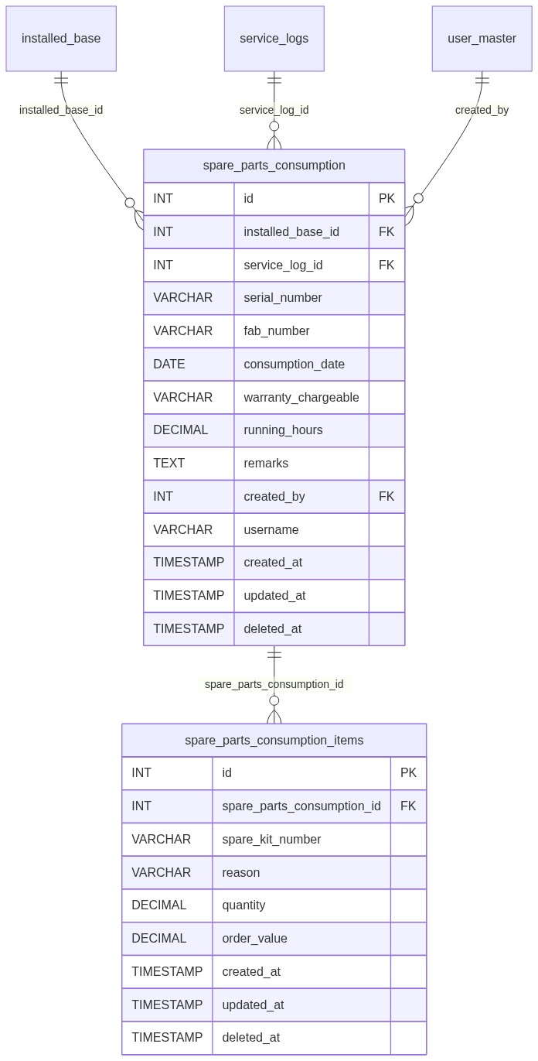
Figure 2 — Entity relationship diagram

5.2 Table: spare_parts_consumption
Column | MySQL type | Null | Default | Description
id | INT UNSIGNED AUTO_INCREMENT | NO | — | PK
installed_base_id | INT UNSIGNED | NO | — | Logical FK → IB
service_log_id | INT UNSIGNED | YES | NULL | Logical FK → SL
serial_number | VARCHAR(50) | NO | —
fab_number | VARCHAR(50) | YES* | NULL | Required by app
consumption_date | DATE | NO | —
warranty_chargeable | VARCHAR(50) | NO | — | SCM option
running_hours | DECIMAL(10,2) | YES* | NULL | Required by app > 0
remarks | TEXT | YES | NULL | App max 1000
created_by | INT UNSIGNED | NO | — | FK → user_master
username | VARCHAR(100) | YES | NULL | List scope
created_at | TIMESTAMP | YES | CURRENT_TIMESTAMP
updated_at | TIMESTAMP | YES | NULL | Update / soft-delete
deleted_at | TIMESTAMP | YES | NULL | Soft-delete

*App treats as required even if DB allows NULL.
Recommended indexes: PK(id), KEY idx_spc_ib (installed_base_id), KEY idx_spc_sl (service_log_id), KEY idx_spc_username (username), KEY idx_spc_deleted (deleted_at).

5.3 Related tables
Table | Relationship | Notes
installed_base | Parent machine | Soft-delete independent
service_logs | Optional parent visit | Soft-delete independent
spare_parts_consumption_items | Line items | Soft-deleted with parent
user_master | created_by | Actor
SCM masters | Logical | warranty_chargeable, reason

spare_parts_consumption_items
Column | MySQL type | Null | Description
id | INT UNSIGNED AUTO_INCREMENT | NO | PK
spare_parts_consumption_id | INT UNSIGNED | NO | Parent
spare_kit_number | VARCHAR(100) | NO | Free text
reason | VARCHAR(50) | NO | SCM reason
quantity | DECIMAL(10,2) | NO | > 0
order_value | DECIMAL(12,2) | NO | ≥ 0
created_at | TIMESTAMP | YES
updated_at | TIMESTAMP | YES
deleted_at | TIMESTAMP | YES | Soft-delete

5.4 Reference / lookup sources
Source | Usage
api/installed_base_link_search.php | Machine Select2
api/service_log_link_search.php | Service Log Select2 (filtered by IB)
SCM warranty_chargeable | Warranty dropdown
SCM reason | Per-item Reason dropdown
IB / SL prefill APIs | Modal autofill

────────────────────────────────

6. API / Backend Design

6.1 Page endpoints (HTML / form POST)
Endpoint | Method | Auth | Description
spare_parts_consumption.php | GET | view | Listing + form panel
spare_parts_consumption.php | POST submit_spare_parts | add / edit | Create or update
spare_parts_consumption_details.php?id= | GET | view + ACL | Details (id base64)
delete_spare_parts_consumption.php?id= | GET | delete + ACL | Soft-delete (id base64)

Key POST fields
Field | Notes
record_id | 0 = create; >0 = update
installed_base_id | Required
service_log_id | Optional
fab_number, serial_number | Required
consumption_date, warranty_chargeable, running_hours | Required
remarks | Optional
spare_parts_multi | 1
spare_parts_items[...] | kit, reason, quantity, order_value

6.2 JSON APIs

POST api/spare_parts_datatable.php
Scoped DataTables. Aggregates first kit (+N more), sum qty/value, distinct reasons, service log label.

GET api/spare_parts_get.php?id=
Parent fields + spare_parts_items[] (+ legacy first-item fields for compatibility).
Errors: Invalid record. / Record not found.

POST api/spare_parts_create.php
{ "success": true, "message": "Spare parts record saved successfully." }
Errors: 422 { "error": "..." } · 401 / 403 / 405.

Prefill — shared shape
{
"service_log_id": "",
"service_log_label": "",
"installed_base_id": 1,
"installed_base_label": "#1 - FAB - Customer",
"customer_name": "",
"dealer_name": "",
"order_id": "",
"fab_number": "",
"serial_number": "",
"machine_model": "",
"warranty_chargeable": "",
"complaint_date": "",
"issue_description": "",
"engineer_name": "",
"visit_date": "",
"action_taken": "",
"closure_date": "",
"running_hours": "",
"service_remarks": ""
}
API | Running hours | Serial
GET api/installed_base_spare_parts_prefill.php | IB hours | Latest SL serial or FAB
GET api/service_log_spare_parts_prefill.php | SL hours else IB hours | From SL

6.3 Supporting lookup APIs
API | Purpose
api/installed_base_link_search.php | Machine Select2
api/service_log_link_search.php | SL Select2 by installed_base_id

6.4 Core PHP module responsibilities
Module / file | Responsibility
includes/spare_parts_helpers.php | from_post, validate, insert/update parent, items insert/sync, create_record, actions HTML
includes/after_market_access_helpers.php | Scope, ACL, add OR gates
includes/system_config_master_helpers.php | Warranty / reason options
includes/rbac_* | Page/API maps
includes/service_log_spare_parts_modal.php | Shared modal markup

────────────────────────────────

7. Validation Rules

7.1 Server-side (spare_parts_validate)
Rule | Error message
IB missing | Machine (installed base) is required.
FAB missing | Fab Number is required.
Serial missing | Serial Number is required.
Date | Consumption Date is required.
Warranty | Warranty / Chargeable is required. / Invalid Warranty / Chargeable selection.
No items | At least one spare part item is required.
Item kit | Spare part item N: Spare Kit Number is required.
Item reason | Spare part item N: Reason is required. / Invalid Reason selected.
Item qty | Quantity is required. / Quantity must be greater than zero.
Item value | Order Value is required. / Order Value must be a valid non-negative number.
Hours | Running Hours is required. / Running Hours must be greater than 0.
Remarks | Remarks cannot exceed 1000 characters.
IB not found | Selected machine was not found in installed base records.
SL mismatch | Selected service record does not belong to the selected machine.
FAB mismatch | Fab Number does not match the selected machine.
Persist fail | Failed to save spare parts record.

7.2 Client-side
Script | Behavior
js/spare_parts_validation.js | Header fields (machine, fab, serial, date, warranty, hours, remarks)
js/spare_parts_items.js | ≥1 item; kit/reason/qty/value rules
js/service_log_spare_parts_modal.js | Modal constraints + same item rules

────────────────────────────────

8. UI Screen Specifications

8.1 Listing — spare_parts_consumption.php
Element | Spec
Title | Spare Parts Consumption
Primary CTA | New Record (if add) → form panel
Grid columns | ID, Serial No., Date, Type, Kit Number, Qty, Order Value (₹), Reason, Service Log, Created At, Action
Kit summary | First kit or KIT (+N more)
Empty | No spare parts records found. / No matching records found.
Row actions | View, Edit, Delete (permission-gated)

8.2 Form panel
Section 1 — Machine & Service Link
Field | Control | Notes
Machine | Select2 | Required
Service Record | Select2 | Optional; depends on machine
Order ID | hidden | Not stored
Fab Number | text/readonly after select | Required
Serial Number | text | Required
Running Hours | number | Required > 0

Section 2 — Spare Parts Details
Consumption Date*, Warranty*, multi-item rows (Kit*, Reason*, Qty*, Order Value*), Remarks, Add Spare Part button.

8.3 Details — spare_parts_consumption_details.php
• Machine & Service Link (IB / SL labels)
• Consumption Details
• Items table + totals
• Recorded By = username
• Empty items: No spare part items recorded.
• Also embeddable on Installed Base Details

8.4 Modals (from listing of IB / SL)
Modal | Host | Prefill
Add Spare Parts Consumption | Installed Base | data-prefill="installed_base"
Add Spare Parts Consumption | Service Log | data-prefill="service_log"

Modal sections: Service Log & Machine Link · Complaint/Service Details (hidden if no SL) · Spare Parts Details.
────────────────────────────────

9. Database Flow

9.1 Create
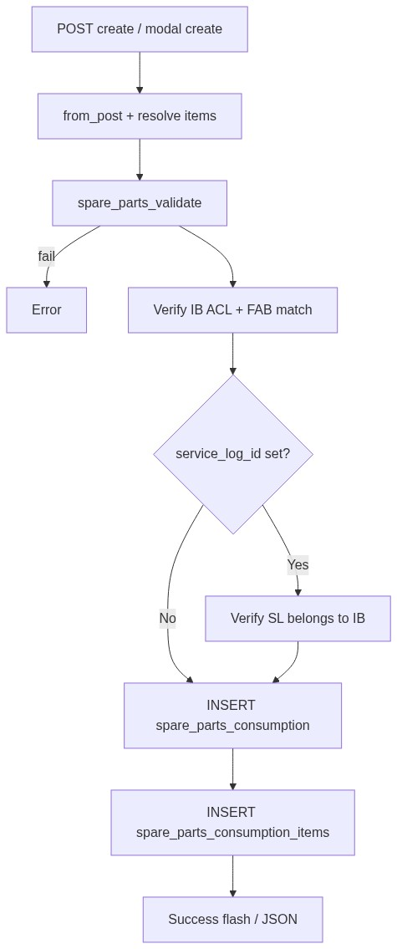
Figure 3 — Create database flow

9.2 Soft-delete
UPDATE spare_parts_consumption
SET deleted_at = CURRENT_TIMESTAMP,
updated_at = CURRENT_TIMESTAMP
WHERE id = :id AND deleted_at IS NULL;

UPDATE spare_parts_consumption_items
SET deleted_at = CURRENT_TIMESTAMP,
updated_at = CURRENT_TIMESTAMP
WHERE spare_parts_consumption_id = :id
AND deleted_at IS NULL;
Confirm UI: Delete this spare parts record?

9.3 List query pattern
SELECT sp.*, aggregates(items), ib.customer_name, ...
FROM spare_parts_consumption sp
LEFT JOIN ... items / IB / SL
WHERE /* after_market_list_scope on sp */
AND /* optional DataTables search */
ORDER BY {col} {ASC|DESC}
LIMIT :limit OFFSET :offset;
────────────────────────────────

10. Sequence Diagram

10.1 Create / update on Spare Parts page
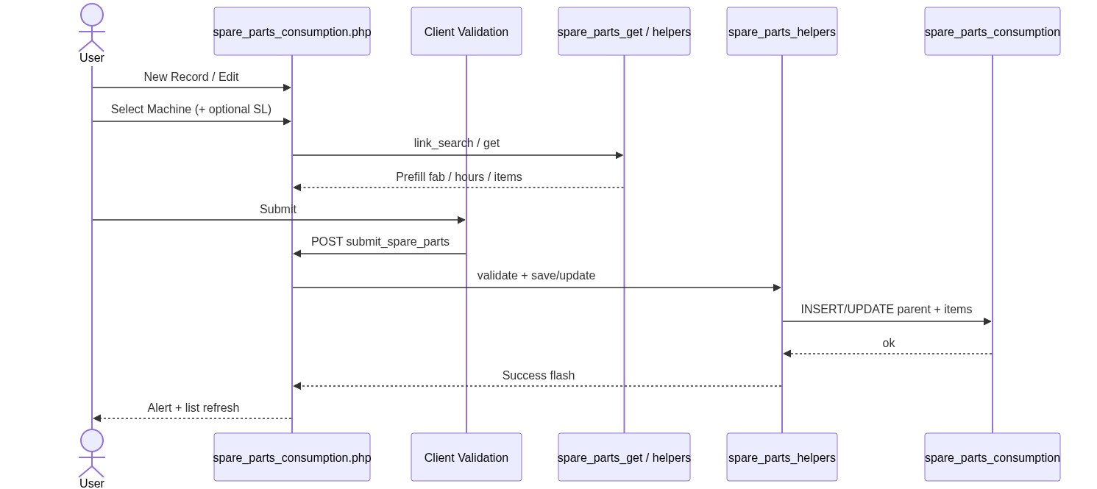
Figure 4 — Sequence: Create / update on Spare Parts page

10.2 Add Spare Parts from Installed Base / Service Log row
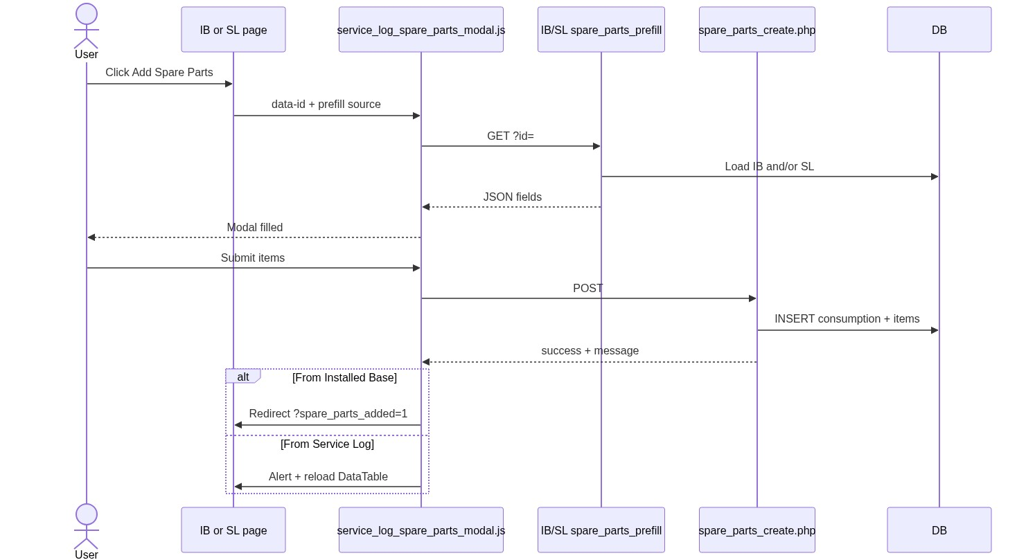
Figure 5 — Sequence: Add Spare Parts from IB / SL row
────────────────────────────────

11. Activity Diagram
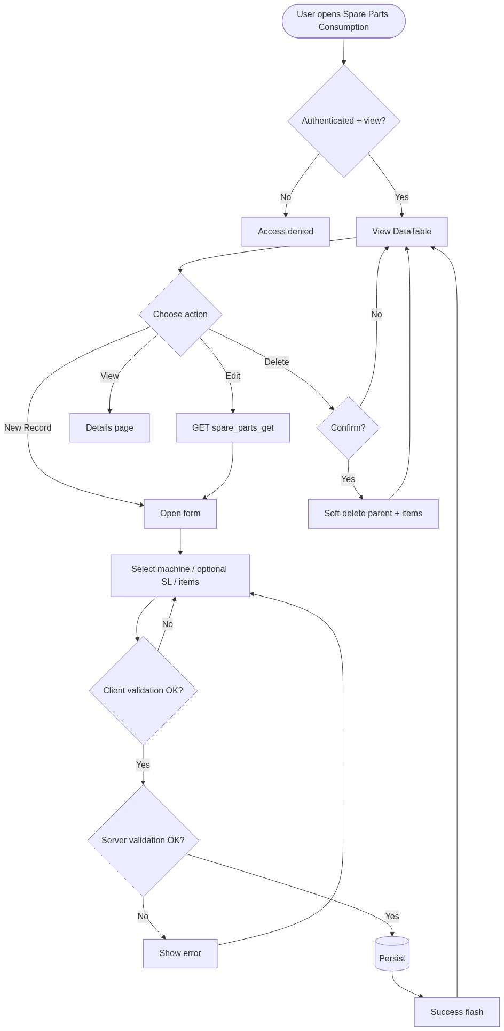
Figure 6 — Activity diagram
────────────────────────────────

12. Class / Module Diagram
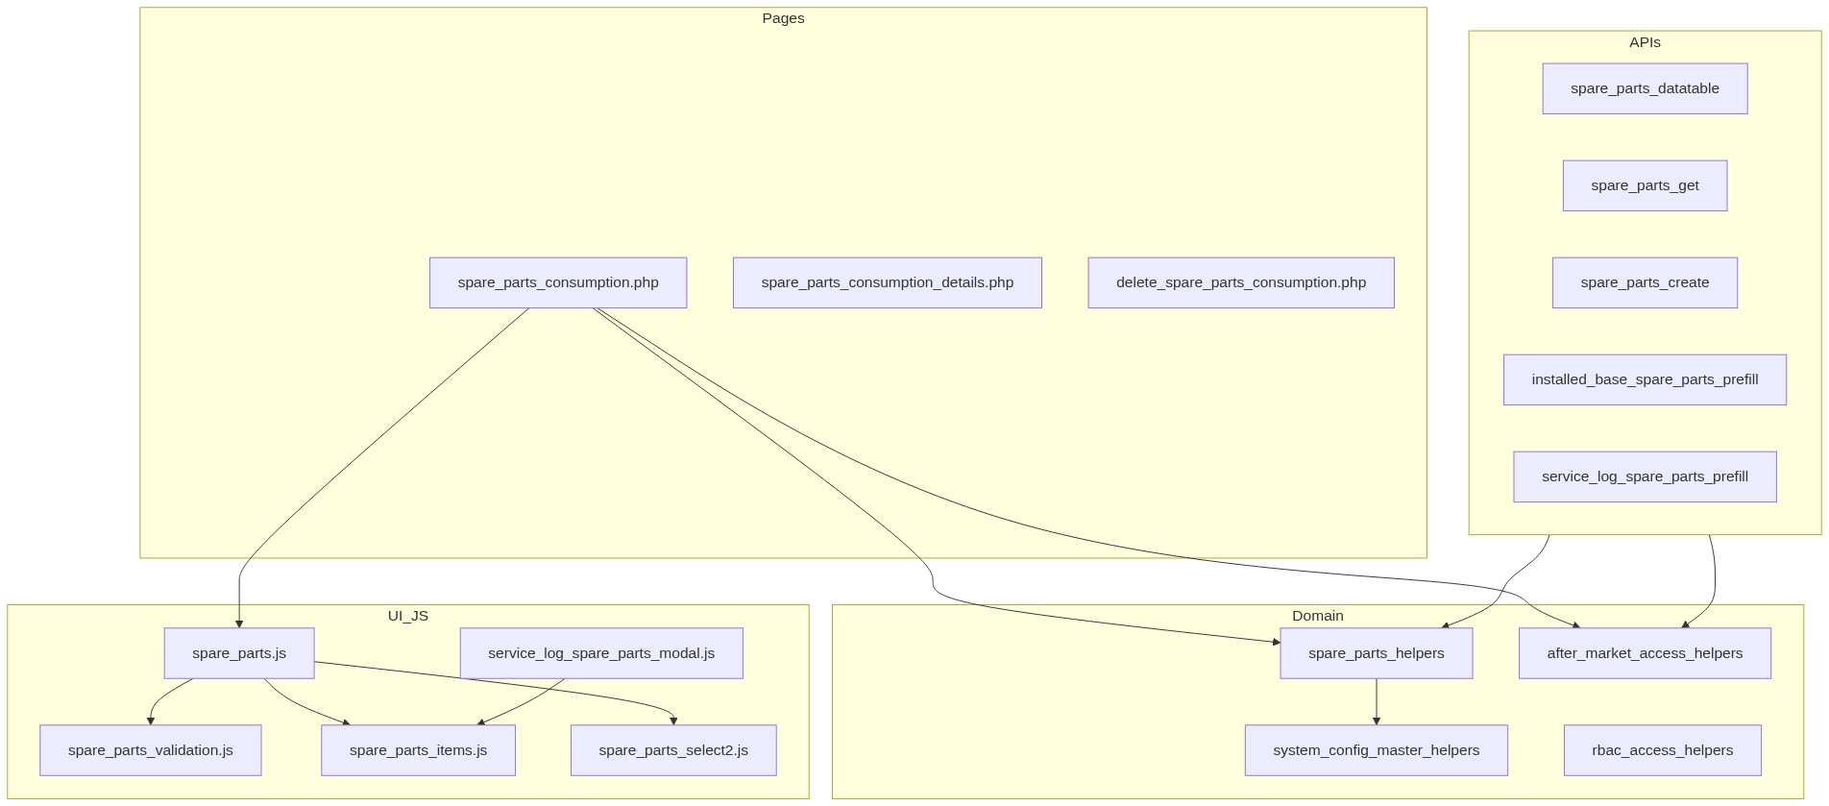
Figure 7 — Class / module diagram

12.1 Key functions
Function | Role
spare_parts_from_post() / spare_parts_items_from_post() | Map POST
spare_parts_resolve_items() | Multi or legacy single-item
spare_parts_validate() / spare_parts_validate_item() | Server validation
spare_parts_insert_parent() / spare_parts_update_parent() | Header CRUD
spare_parts_insert_items() / spare_parts_sync_items() | Line items
spare_parts_save_consumption() / spare_parts_update_consumption() | Page save paths
spare_parts_create_record() | Modal/API create
spare_parts_soft_delete_items_for_consumption() | Cascade soft-delete items
spare_parts_entry_actions() | Row action HTML
spare_parts_format_kit_summary() / totals helpers | Listing/details display
after_market_user_can_add_spare_parts() | Create OR gate

────────────────────────────────

13. Folder Structure
ComplaintManagement/
├── spare_parts_consumption.php
├── spare_parts_consumption_details.php
├── delete_spare_parts_consumption.php
├── api/
│ ├── spare_parts_datatable.php
│ ├── spare_parts_get.php
│ ├── spare_parts_create.php
│ ├── installed_base_spare_parts_prefill.php
│ └── service_log_spare_parts_prefill.php
├── includes/
│ ├── spare_parts_helpers.php
│ ├── spare_parts_record_details_section.php
│ ├── service_log_spare_parts_modal.php
│ └── after_market_access_helpers.php
├── js/
│ ├── spare_parts.js
│ ├── spare_parts_validation.js
│ ├── spare_parts_items.js
│ ├── spare_parts_select2.js
│ └── service_log_spare_parts_modal.js
└── docs/
└── LLD_Spare_Parts_Consumption_Module.md
────────────────────────────────

14. Error Handling
Layer | Pattern
Page POST | $error_message / $success_message
Delete / ACL | Session flash + redirect listing
JSON APIs | 401 / 403 / 404 / 405 / 422 + {"error":"..."}
Client AJAX | Modal/page Bootstrap alerts or alert()

14.1 Common messages
Message | When
Access denied. You do not have permission for this action. | RBAC / ACL
Access denied. You do not have permission to add/edit spare parts records. | Add/edit gate
Access denied. You do not have permission to edit this record. | Record ACL
Unable to resolve logged-in user. | Missing user id
Record not found or already deleted. | Missing target
Failed to save spare parts record. / Failed to delete spare parts record. | Persist failure
Invalid spare parts record. | Bad delete id
Unauthorized. | API unauthenticated
Unable to load installed base details... / Unable to load service log details. | Prefill fail (JS)

────────────────────────────────

15. Security Considerations
Area | Control
SQL Injection | PDO prepared statements
XSS | Escaped output; careful action HTML
CSRF | Session POST; recommend CSRF tokens on mutating endpoints
Authentication | Portal session
Authorization | RBAC + after-market scope + record ACL + create OR gates
IDOR | Details/delete/get ACL; base64 IDs obfuscation only
Soft-delete | Filter deleted_at IS NULL
Mass assignment | Explicit from_post; order fields not stored on parent

────────────────────────────────

16. Audit Logs

16.1 Built-in field-level audit
Field | Behavior
created_by | Set on parent INSERT
username | Set on parent INSERT (scope)
created_at | DB default
updated_at | Parent update; soft-delete; item sync
deleted_at | Soft-delete parent + items
Details UI | Recorded By = username
updated_by | Not implemented

No dedicated spare-parts audit table. Recommended future: action + before/after JSON + actor + IP.
────────────────────────────────

17. Test Cases

17.1 Functional
ID | Scenario | Expected
TC-01 | User with view opens listing | Scoped DataTable loads
TC-02 | Create with IB + ≥1 valid item | Success flash; row appears
TC-03 | Create without items | Validation error
TC-04 | Qty 0 or negative order value | Validation error
TC-05 | Invalid SCM reason/warranty | Validation error
TC-06 | FAB mismatch vs IB | Validation error
TC-07 | SL linked to different IB | Validation error
TC-08 | Running hours blank / 0 | Validation error
TC-09 | Update accessible record | Update success
TC-10 | Soft-delete | Parent + items soft-deleted; gone from list
TC-11 | Add from IB row | Prefill IB hours; redirect spare_parts_added=1
TC-12 | Add from SL row | Prefill SL/IB hours; success alert + table reload
TC-13 | Optional SL cleared | Saves with service_log_id NULL
TC-14 | Multi kits | Listing shows KIT (+N more); details lists all
TC-15 | Sales coordinator scope | Sees assigned usernames only
TC-16 | Admin list | Sees all active
TC-17 | User with only spare-parts add (no IB add-SP) | Can create on SP page / SL modal; not IB row if IB perm missing
TC-18 | Remarks > 1000 | Validation error

────────────────────────────────

18. Assumptions & Dependencies

18.1 Assumptions
1. Users authenticate via portal session (user_master).
2. RBAC for spare-parts-consumption and IB add-spare-parts-consumption are seeded.
3. Installed Base exists before consumption; Service Log is optional.
4. SCM masters for warranty and reason are maintained.
5. Soft-delete is the only delete path; no cascade from IB/SL.
6. Document target stack is Core PHP + MySQL; repo currently runs PostgreSQL.

18.2 Dependencies
Dependency | Purpose
PHP PDO + MySQL (or PostgreSQL) | Persistence
Session + RBAC | AuthZ
Installed Base / Service Log modules | Parent links + modals
System Config Master | Warranty / reason
jQuery + Select2 + DataTables + Bootstrap | UI
validate.js | Client validation
current_username_helpers | Actor identity

────────────────────────────────

Appendix A — Success flash query flags
Source | Message
Page create | Spare parts record saved successfully.
Page update | Spare parts record updated successfully.
Delete (session) | Spare parts record deleted successfully.
Modal create JSON | Spare parts record saved successfully.
installed_base.php?spare_parts_added=1 | Spare Parts Consumption added successfully.

────────────────────────────────

Appendix B — Select2 control map
Control | Element | API / mode
Machine / IB | #sparePartsMachineSelect | api/installed_base_link_search.php
Service Log | #sparePartsServiceLogSelect | api/service_log_link_search.php?installed_base_id=
Warranty (page) | #sparePartsWarrantySelect | Static SCM
Warranty (modal) | #slSparePartsWarrantySelect | Static SCM
Reason (per item) | Item reason selects | Static SCM reason
Spare Kit Number | text input | Not Select2 (free text, max 100)

────────────────────────────────
End of LLD — Spare Parts Consumption Module

